**AWS Advanced Projects (Day7-Day8)**

**========================================**

**PROJECT 1: VPC Peering**

**Task 1:** VPC List

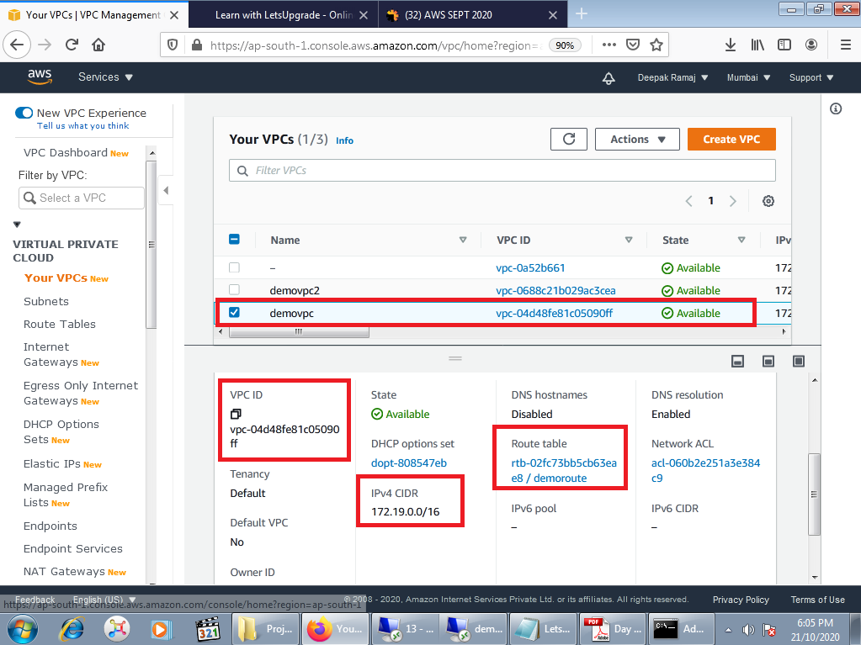

Fig. 1.1 VPC1

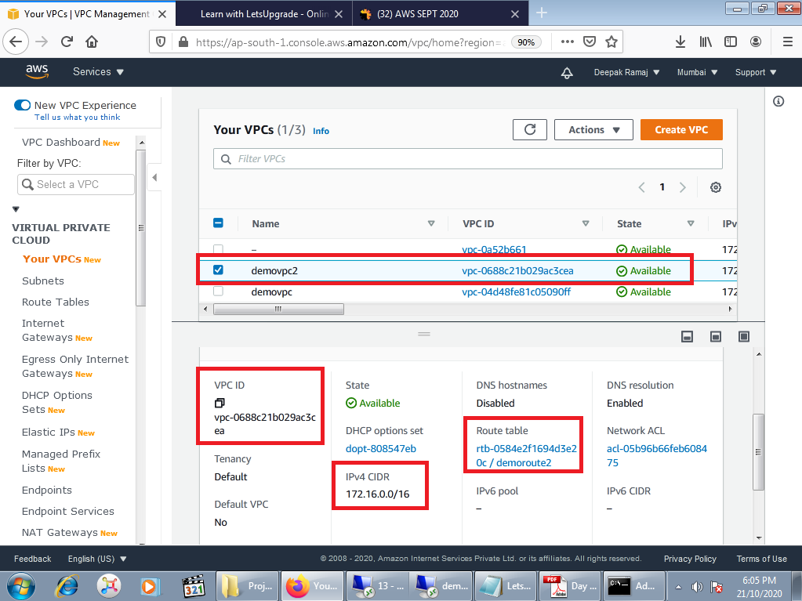

Fig. 1.2 VPC2

**Task 2:** Internet Gateway List

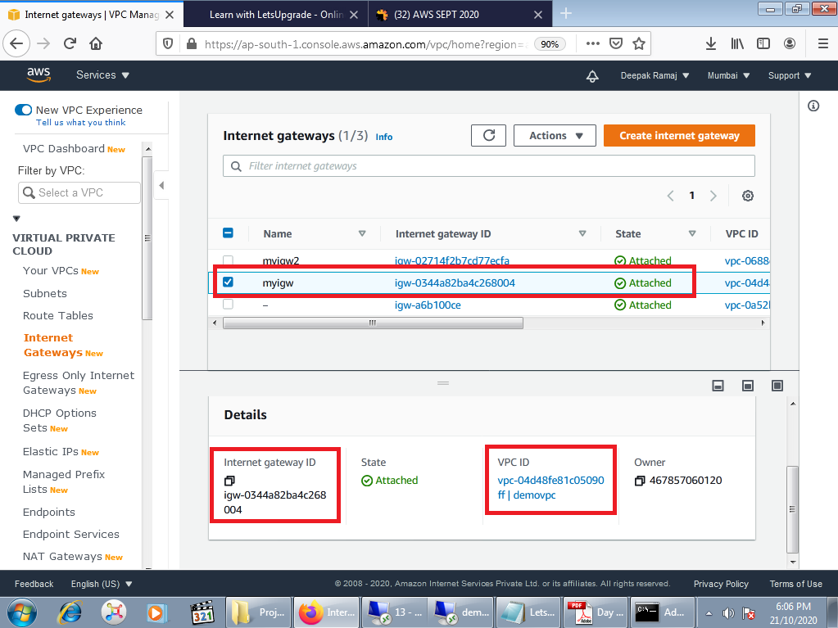

Fig. 2.1 IGW1

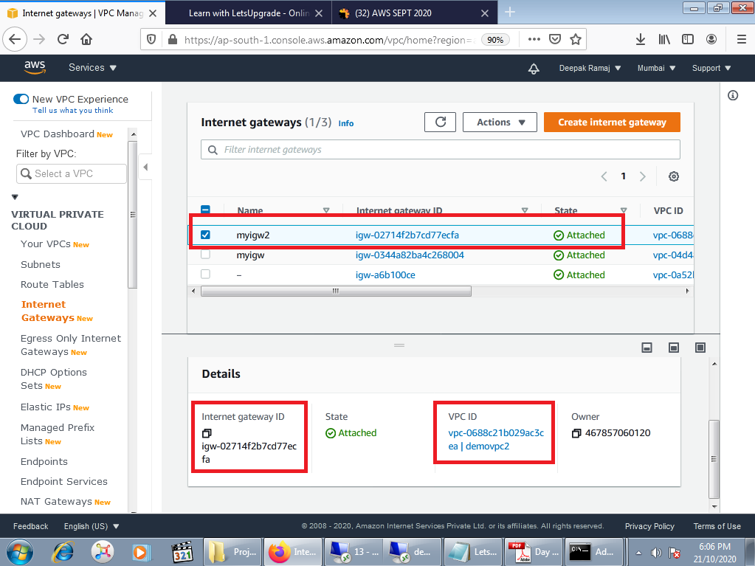

Fig. 2.2 IGW2

**Task 3:** Route List

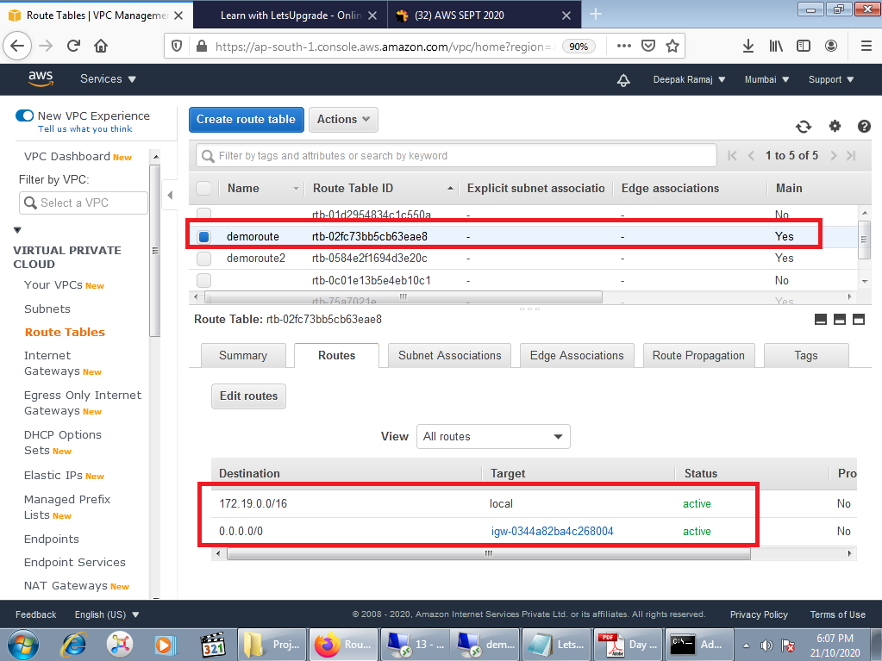

Fig 3.1 Route 1

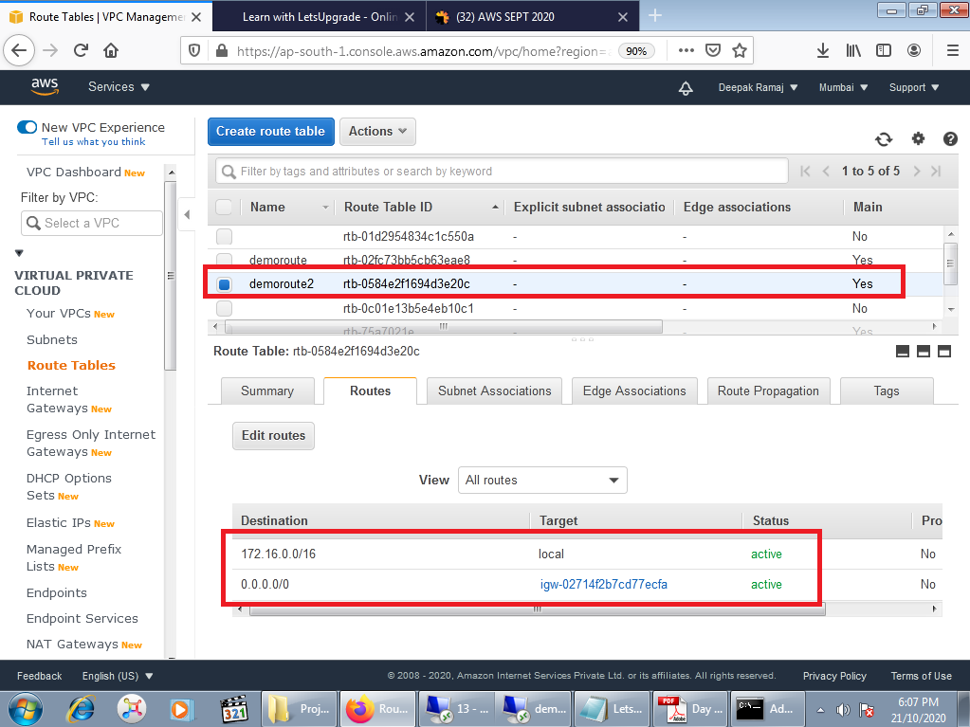

Fig 3.2 Route 2

**Task 4:** Subnet List

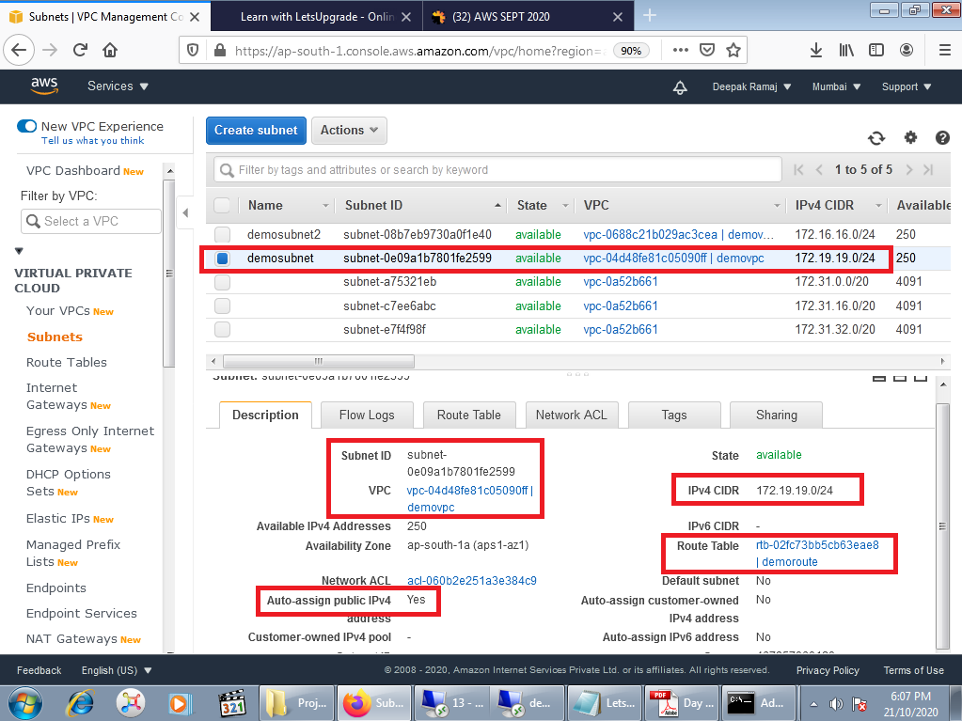

Fig 4.1 Subnet List 1

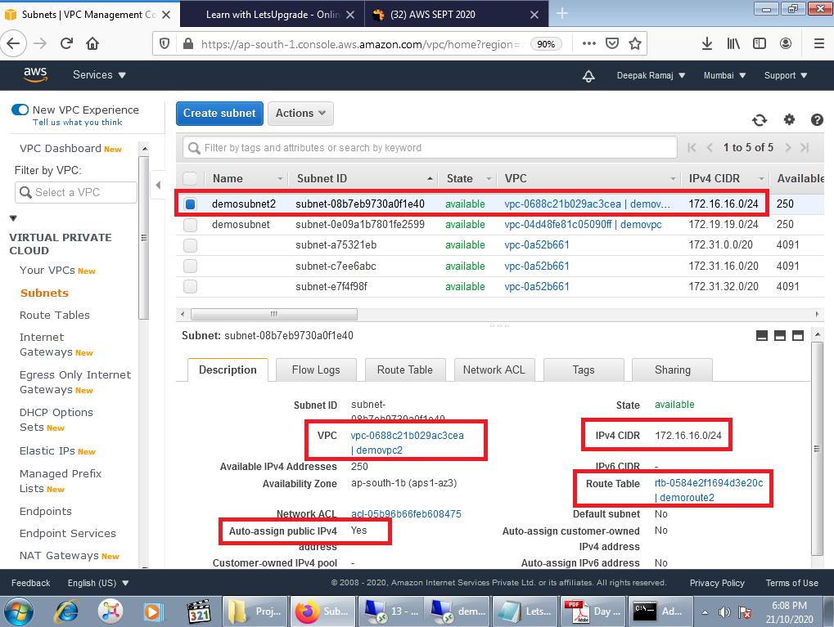

Fig 4.2 Subnet List 2

**Task 5:** Instance Detail

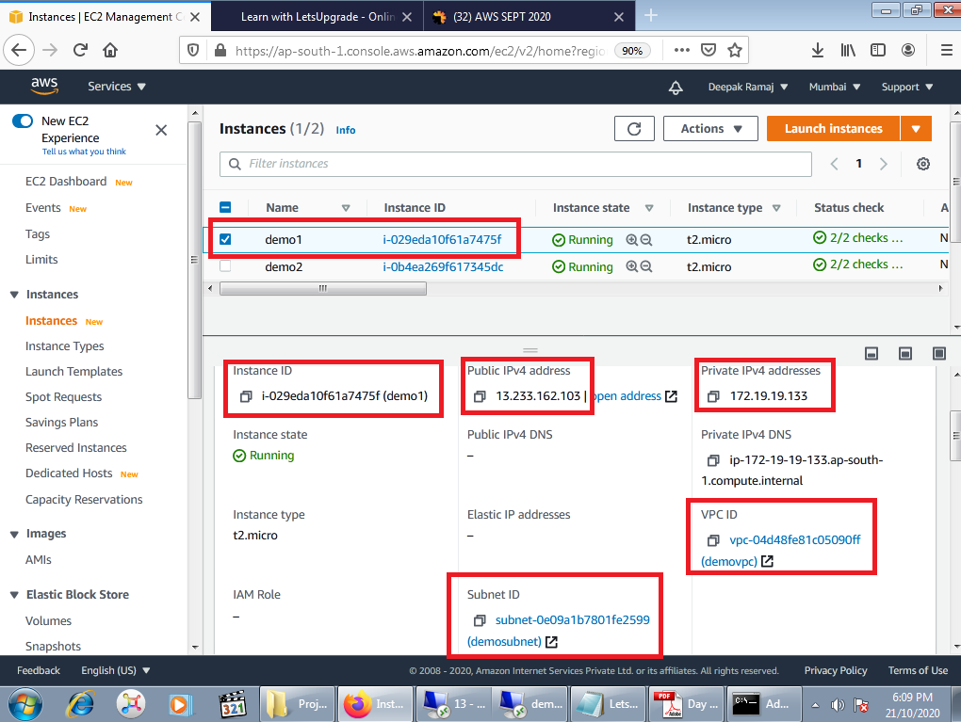

Fig 5.1 Instance 1

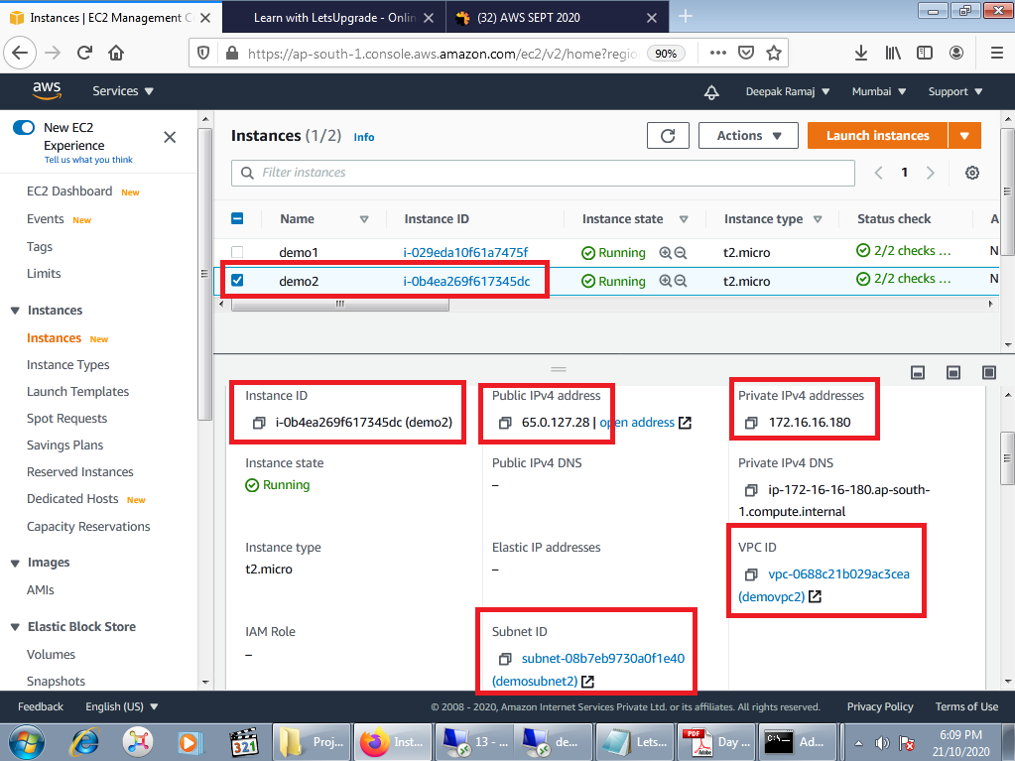

Fig 5.2 Instance 2

**Task 6:** Success public IP and Request timeout for private IP

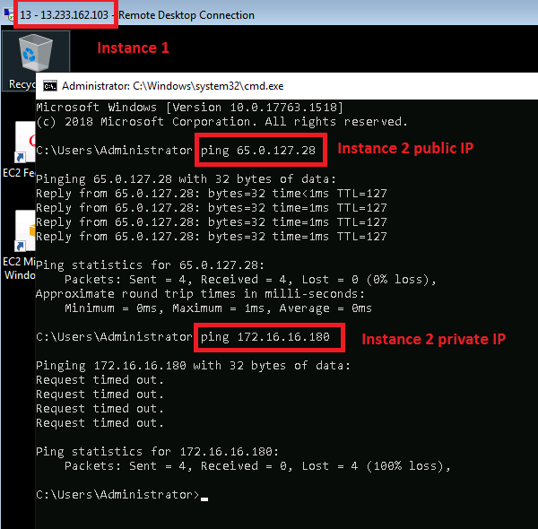

Fig 6.1 Instance 2 public and private IP pinging from Instance 1

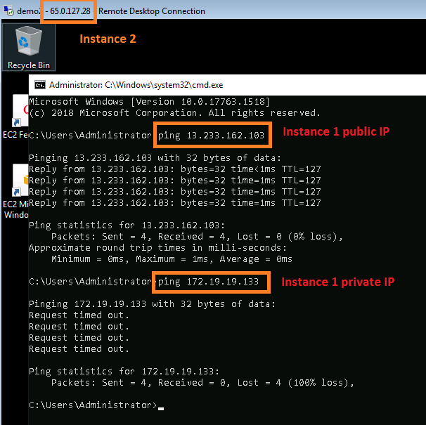

Fig 6.2 Instance 1 public and private IP pinging from Instance 2

**Task 7:** Peering with requestor and acceptor

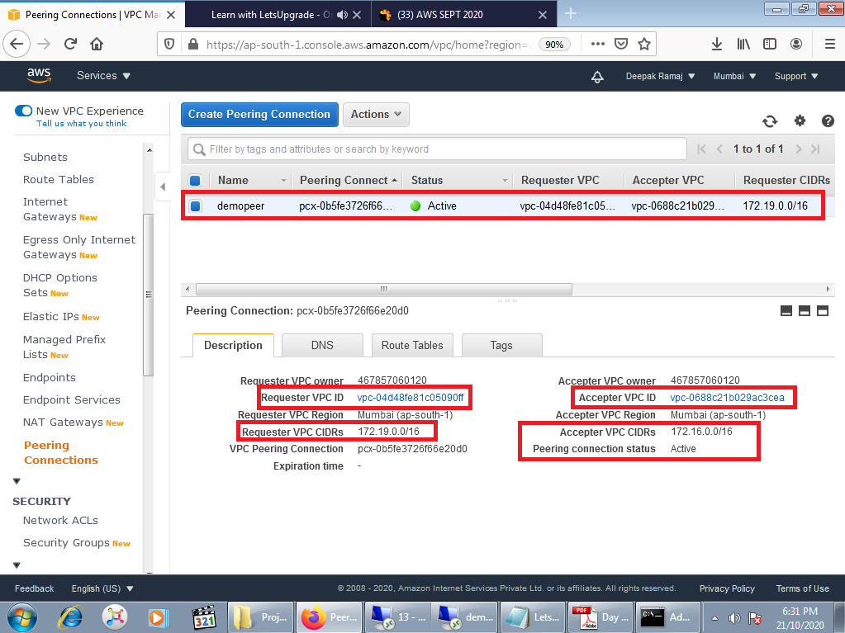

Fig 7.1 Peering connection

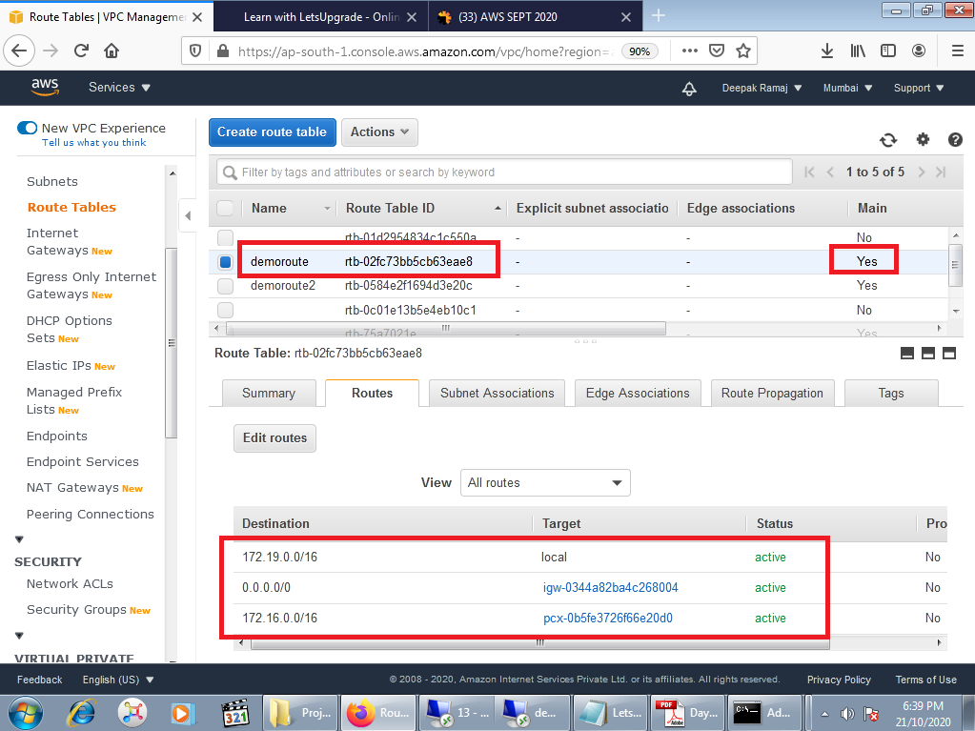

Fig 7.2 Edit route 1 as Requestor

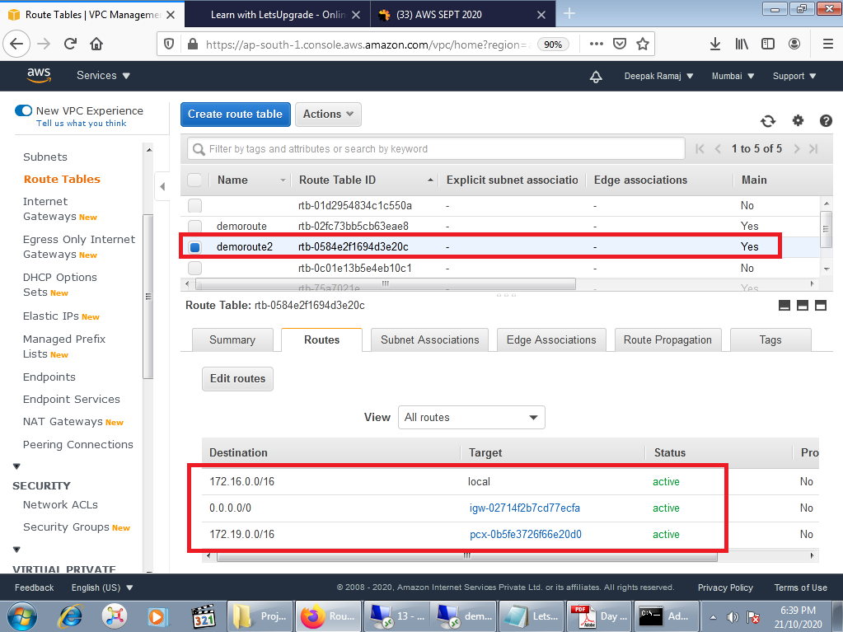

Fig 7.3 Edit route 2 as Acceptor

**Task 8:** Success for private IP

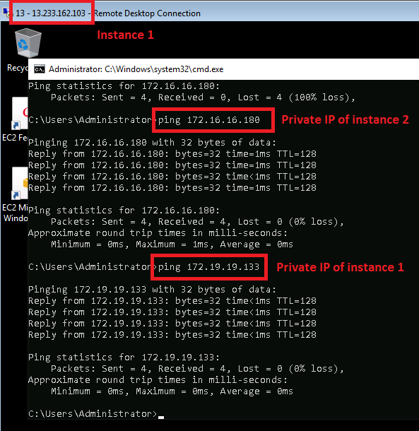

Fig 8.1

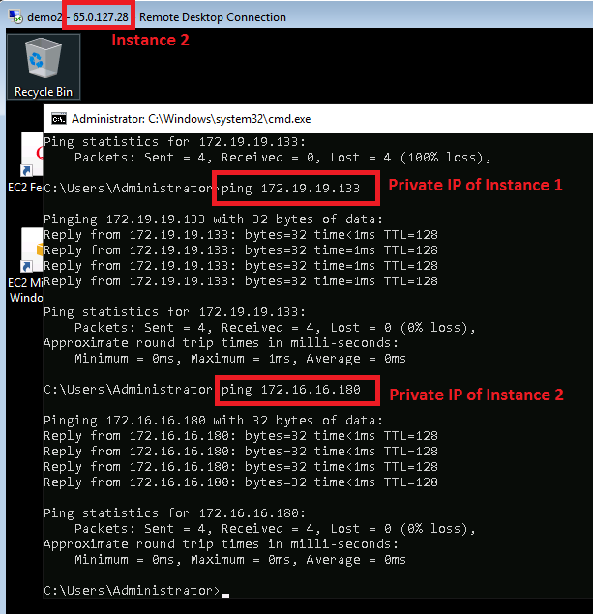

Fig 8.2

**PROJECT 2: IAM**

**Task 1**:Creating users without permissions-IAM password policy check

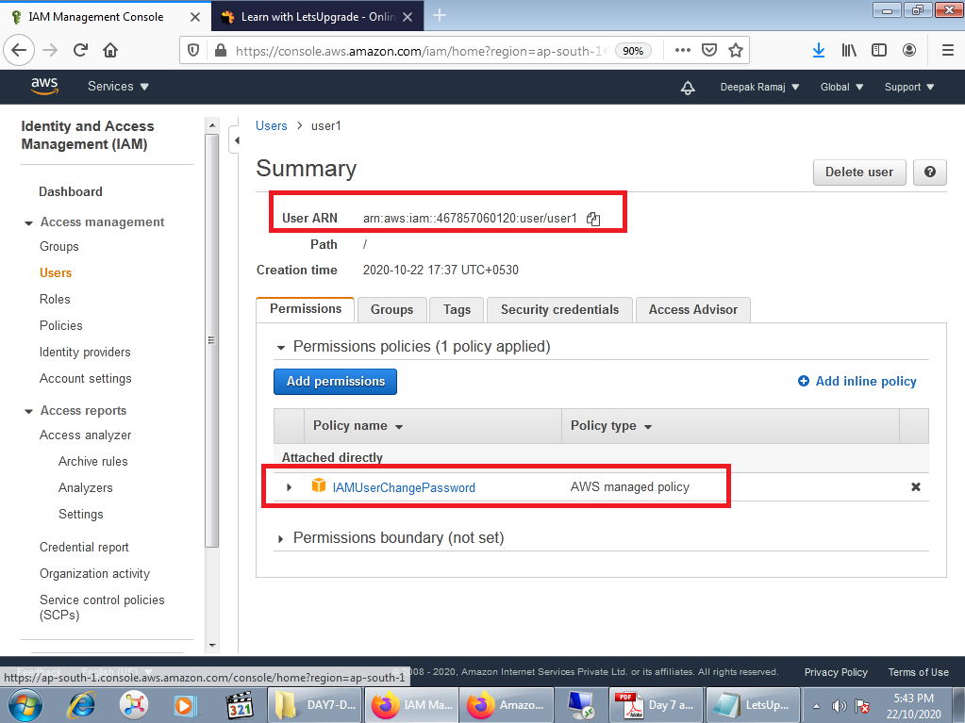

**Task 2**:Creating users without the IAM password policy

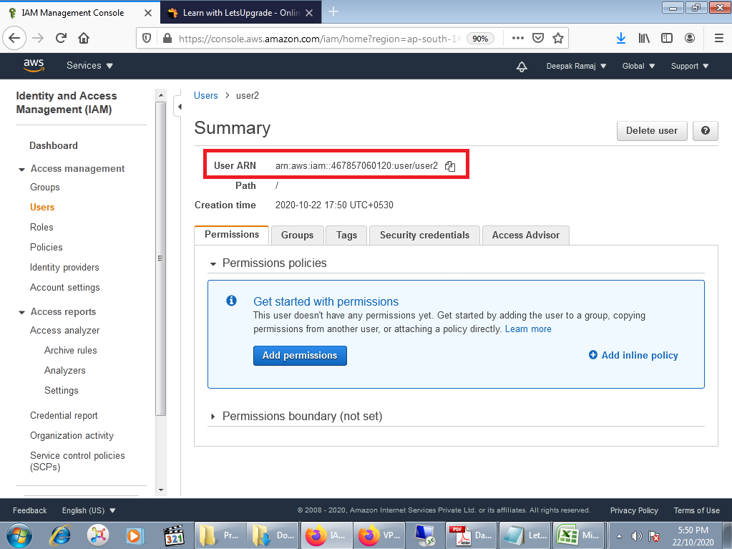

**Task 3**:Create a user with S3 full access

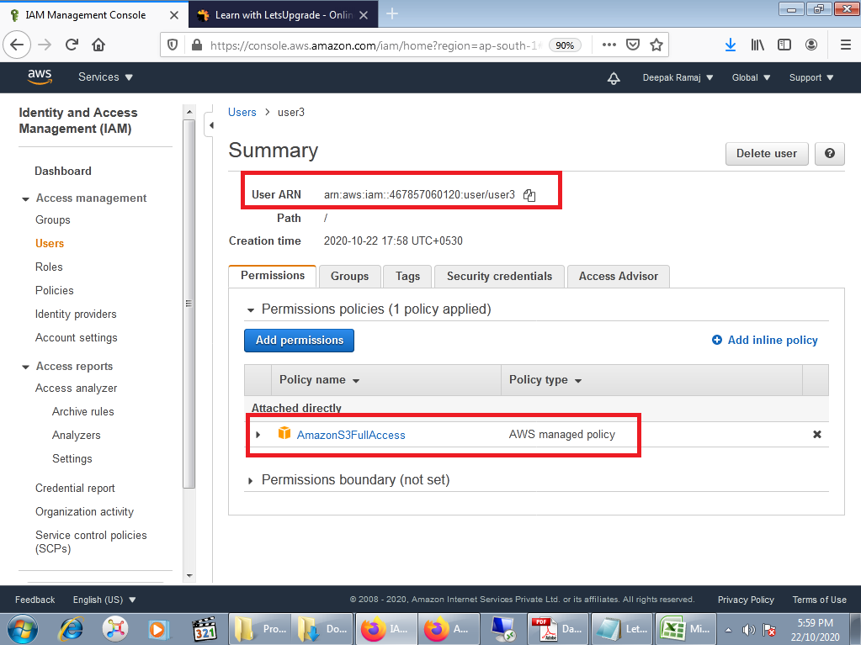

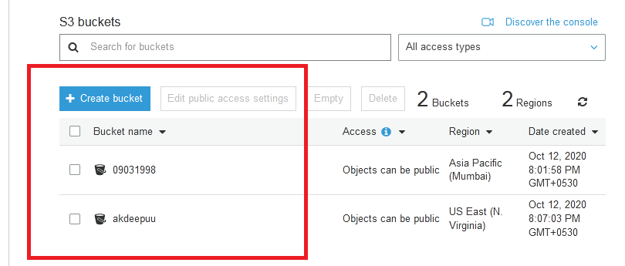

**Task4:** Create a group with ec2 full access

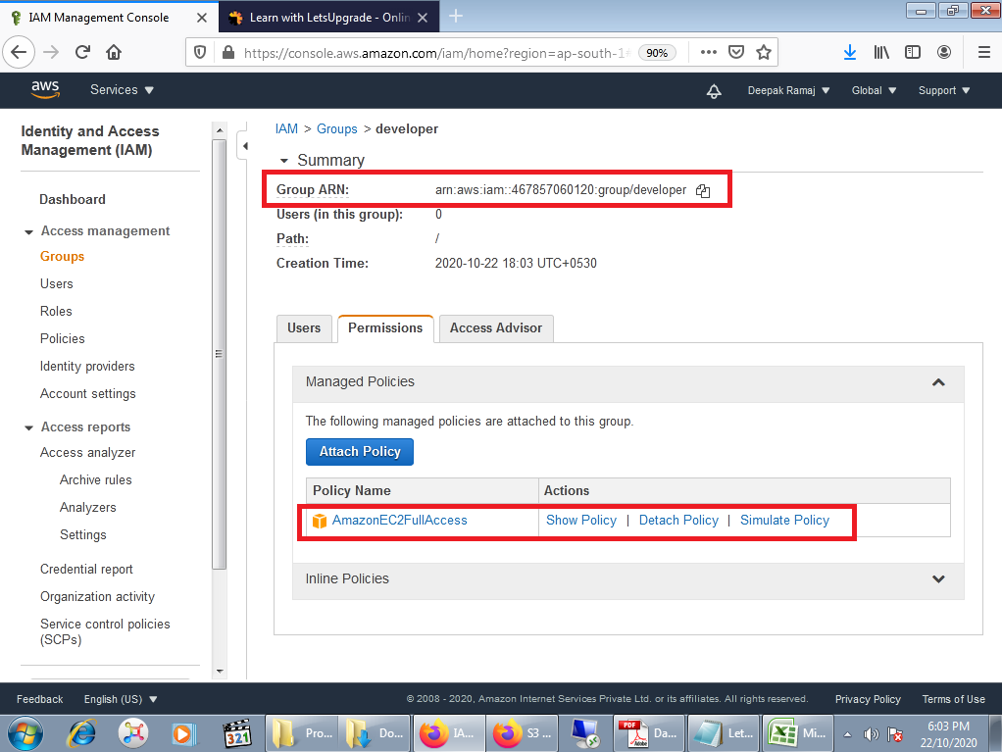

**Task 5**: Add user to a group and check if user policy and the group policy is reflecting on the user

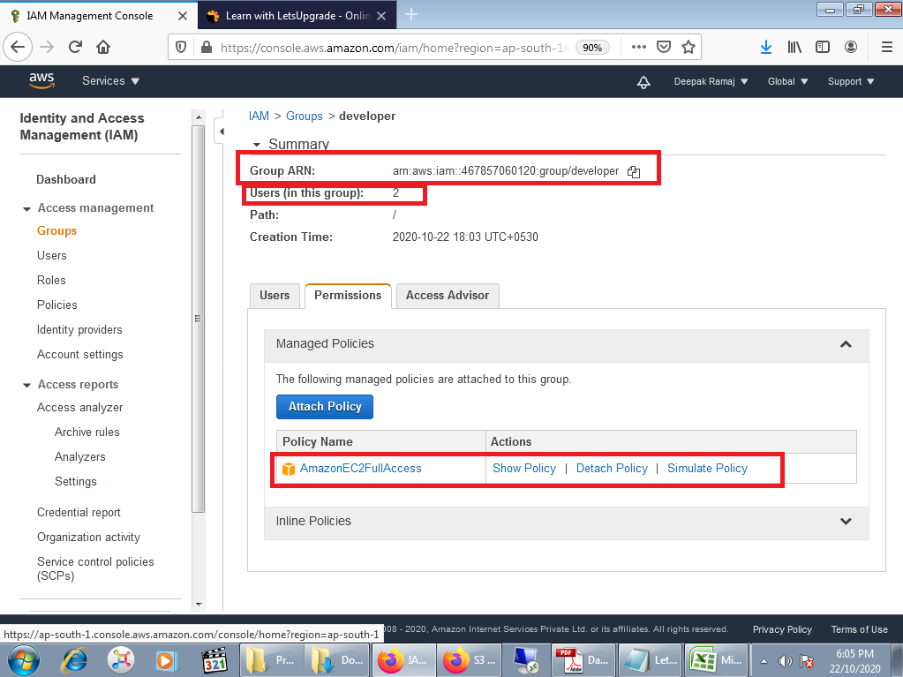

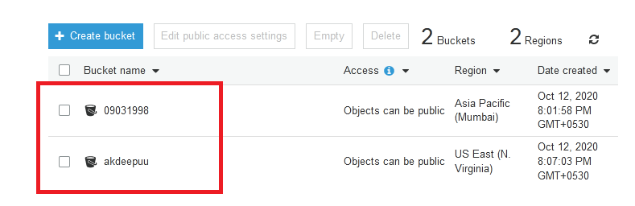

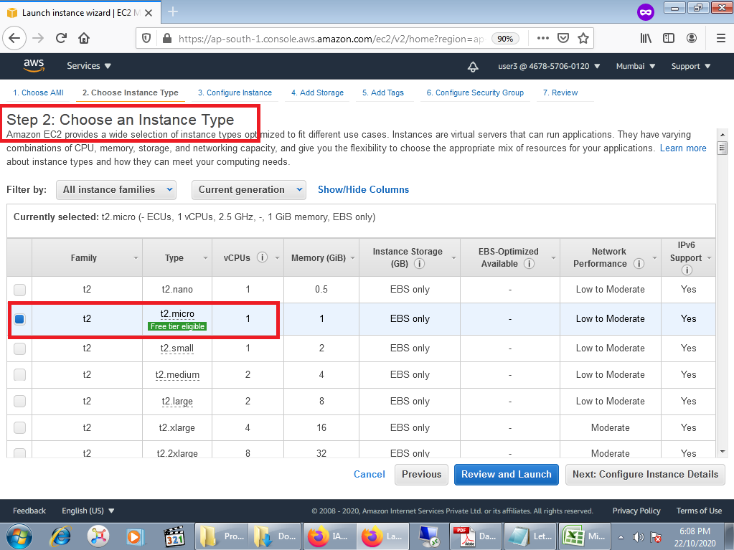

**Task 6**:Copy policies from the existing user

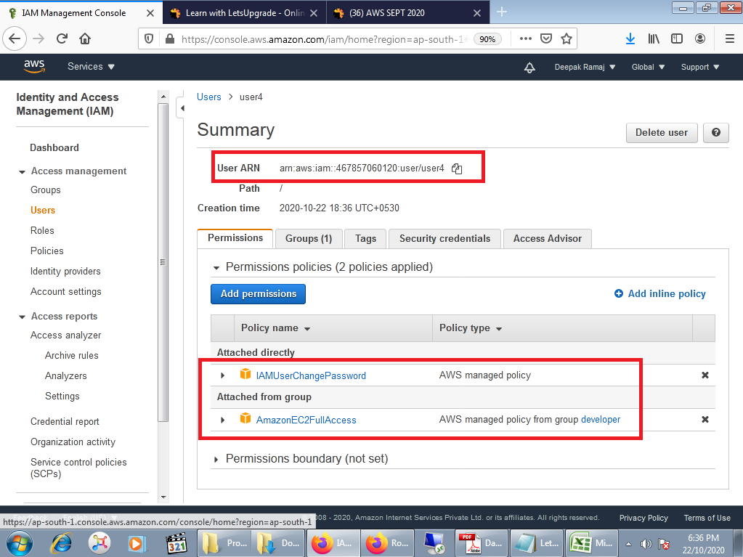

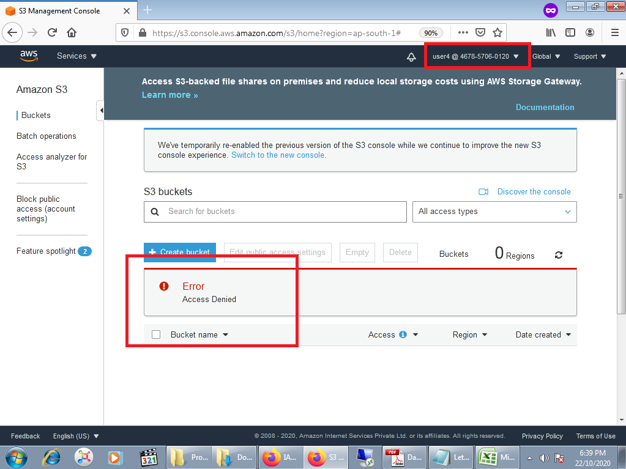

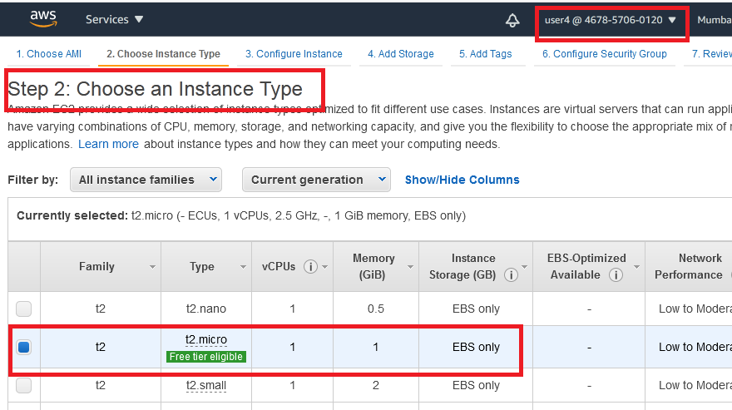

**Task 7:**Add user to a group in the process of creating a user

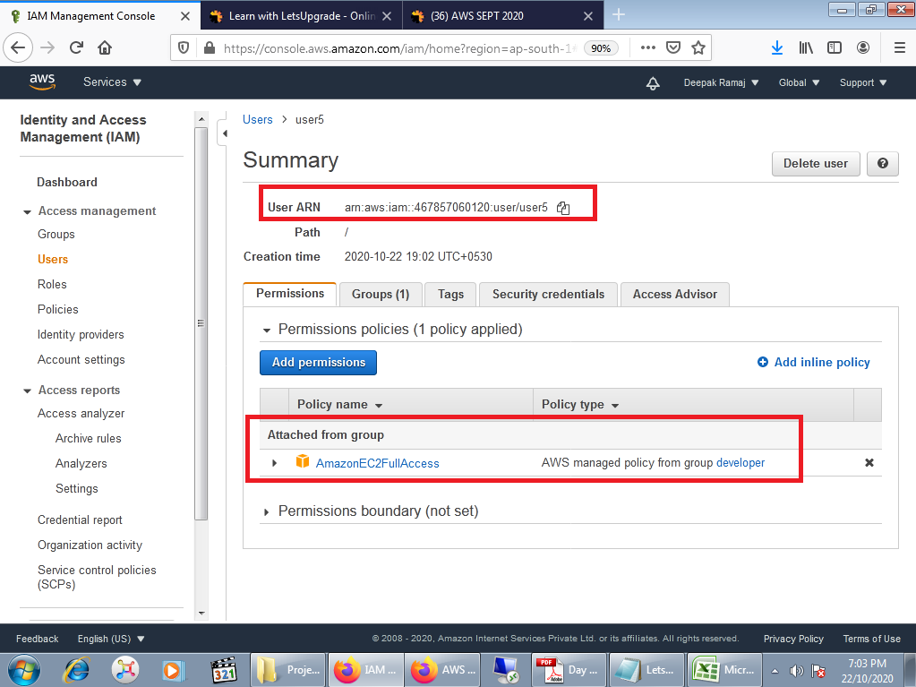

**Task8:** setting a password policy

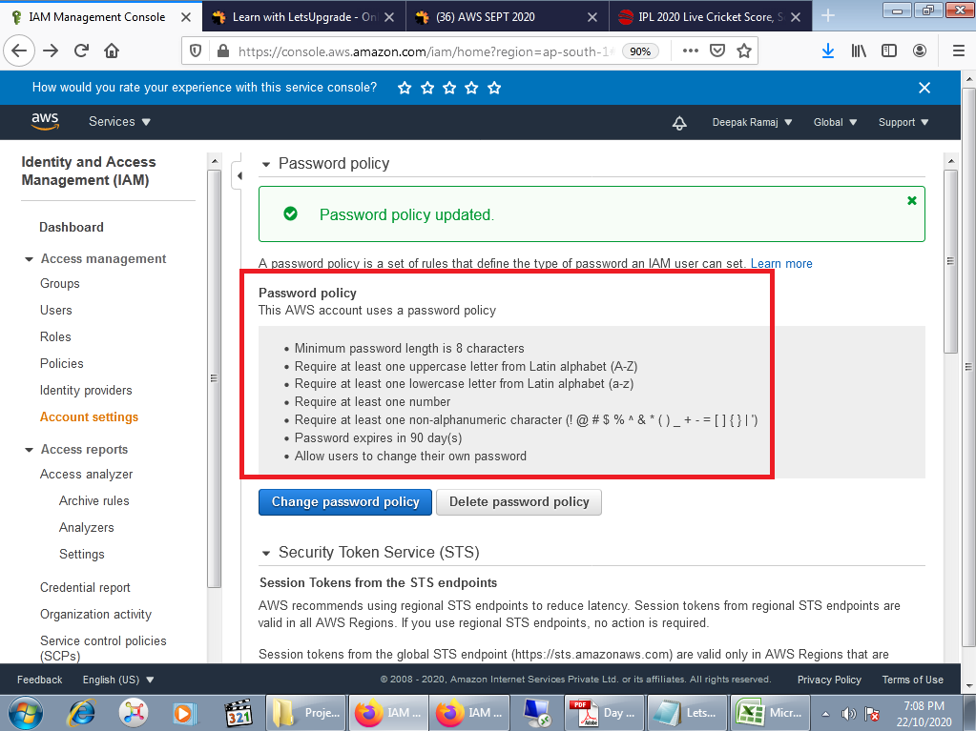

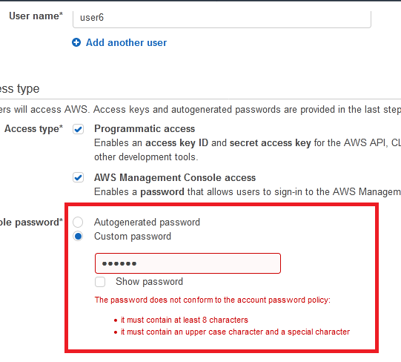

**Task 9**:Enabling MFA and using an MFA device

